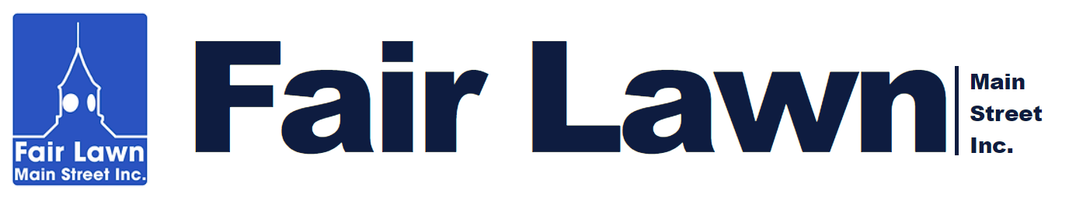

Business Innovation Micro-Grant Program

Fair Lawn Main Street, Inc. (FLMS) is offering Business Innovation Micro-Grants (BIG) to our districts’ small, independent businesses. These grants are capped at $1,000 and are specifically tied to FLMS-approved technical assistance provision to the business owners. Such technical assistance may include façade and storefront design, visual merchandising, marketing, branding, online presence and e-commerce, business accounting and finance, store layout, point of sale options, enhancing the customer experience, and other topics as approved by FLMS.

Other examples may include (but are not limited to) actions that:
- Introduce new products and service lines
- Combine products and services with experiences that enhance customers’ knowledge and enjoyment (demonstrations, classes, events)
- Support new collaborations between businesses that extend the market reach of each
- Create “store within a store” opportunities (pop ups or permanent installations)
- Increase a business’s technological capacity to sell online (such as developing an e-commerce enabled site) while retaining the physical presence in the NPP District
- Experiment with or create new venues for sales
- Support other innovative approaches to sales, design and delivery that will increase businesses’ connection to new markets; and
- Create or enhance marketing, branding, and graphic design efforts (for physical and online presence.)

The ultimate goal is to help our businesses implement innovations in business management practices and the physical or virtual store experience that will attract more customers and increase revenues.

Eligible grant applications will:
- Be signed off on by the technical assistance provider.
- Explicitly describe the intended results that the innovation is expected to foster; and
- Show how the business will assess the effectiveness of the grant.

Available Funding
Eligible projects may receive a direct grant. The business’ commitment to implement the technical assistance plan created for/with them serves as the match. Awards may range up to $1,000 depending on the project. BIG funds are limited to $1,000 per year per eligible River Road and Broadway district business.

Business Innovation Micro-Grant Program Process

Application Process
Business owners should contact the Fair Lawn Main Street, Inc. (FLMS) Executive Director to discuss their project and determine if it meets the criteria for BIG consideration.

BIG applications are accepted on a rolling basis and funding is provided based on availability and the fit of projects with the goals of the program. FLMS has the right to reject any project that it deems not to meet the goals of the program at its sole discretion or to limit the funding to any or all projects in order to provide assistance to the maximum number of applicants.

- Written notification of project approval will be provided by FLMS in writing. If work or procurement starts prior to a written notice of approval being provided no grant funds will be disbursed.

- Once work or procurement is complete the applicant will provide proof of payment for all expenditures to receive matching grant funding. FLMS will provide a check for the reimbursement within 2-4 weeks after proof of expenditures is received.

- In specific cases, based on demonstrated need of the grantee, FLMS may distribute funds in advance of grantee expenditures. If this is a concern, please discuss with FLMS as part of the grant application process.

Project Completion Deadline
All FLMS BIG funded projects must be completed within three months of the agreed upon start date. The term “project completion” means that the innovation project has been implemented as specified in the approved application and that the business, with the FLMS Executive Director, has assessed the success of the innovation, and identified next steps. Failure to complete the project on time will deem the project owner ineligible for reimbursement of costs incurred or require the repayment of any advanced funds.

For more information, please contact:
Ryan Greff, Executive Director
Fair Lawn Main Street
Email: rgreff1@ramapo.edu
Phone: 551-795-2265

Business Innovation Micro-Grant Program Application

1. APPLICANT CONTACT INFORMATION

Your Name: ___________________________________________

Applicant Business Name: ___________________________________________

Applicant Address: ___________________________________________

___________________________________________

Applicant Cell Phone: ___________________________________________

Applicant E-mail: ___________________________________________

Technical Assistance Provider: ___________________________________________

If a collaboration, name and provide contact information for partner(s) below:

2. PROJECT DETAILS

My business is in the River Road District: _____ My business is in the Broadway District: _____

NEED/GOALS
Please describe the need for and goals for this BIG funded project. Please include or attach the specific recommendation(s) from the technical assistance provider listed above:

PLAN
Please outline the steps you will take to implement this project and the timeline for taking them:

ASSESSMENT:
How will you assess the success of this project?

3. PROJECT COST

Estimated Total Project Cost: $__________________

FLMS Portion of Project Cost: $__________________ (Up to $1,000)

Private Portion of Project Cost: $___________________ (if any)

4. CERTIFICATION

I, the undersigned, certify that all information provided herein is true and accurate to the best of my knowledge.

______________________________________________ _____________
Applicant Signature Date

______________________________________________
Applicant Name

______________________________________________ _____________
Technical Assistance Provider Signature Date

______________________________________________
Technical Assistance Provider Name

______________________________________________ _____________
FLMS Executive Director Signature Date

______________________________________________
FLMS Executive Director Name

